Reports to: Head of London-wide Services
Working closely with: Quality Assurance Officer [Debt]
Direct line reports: None
Salary: £35,000 per annum
Working hours: 35 hours per week
Location: 28 Commercial Street, London E1 6LS / 52 Old Castle Street, London E1 7AJ

Introduction:

Toynbee Hall is a charity where people come for excellent local services and where they can share ideas and experience, gather information and knowledge that we use together to take action to change lives and eradicate poverty. Our programmes include free advice services, financial inclusion services, wellbeing services, including work with older people and community learning services supporting young people and new migrants.

Funded by the Single Finance Guidance Body (SFGB), previously the Money Advice Service (MAS), Toynbee Hall is the lead partner of a London-wide free face-to-face debt advice partnership which supports over 25,000 Londoners with their debt and money problems each year. Our trained and accredited advisors are based across 28 partner organisations and help with all types of money worries from rent and council tax arrears to credit card and catalogue debt.

We can work with clients to prioritise their bills & debts, helping them to write letters and advocating on their behalf.

Job purpose:

  - To support and monitor partner organisations, ensuring they are able to provide a good quality debt advice service in line with their Grant Agreement

  - To ensure partner organisations remain compliant with all relevant accreditations and quality standards as required by their Grant Agreement

  - To ensure payments to partner organisations are made each quarter in a timely manner

Team structure:

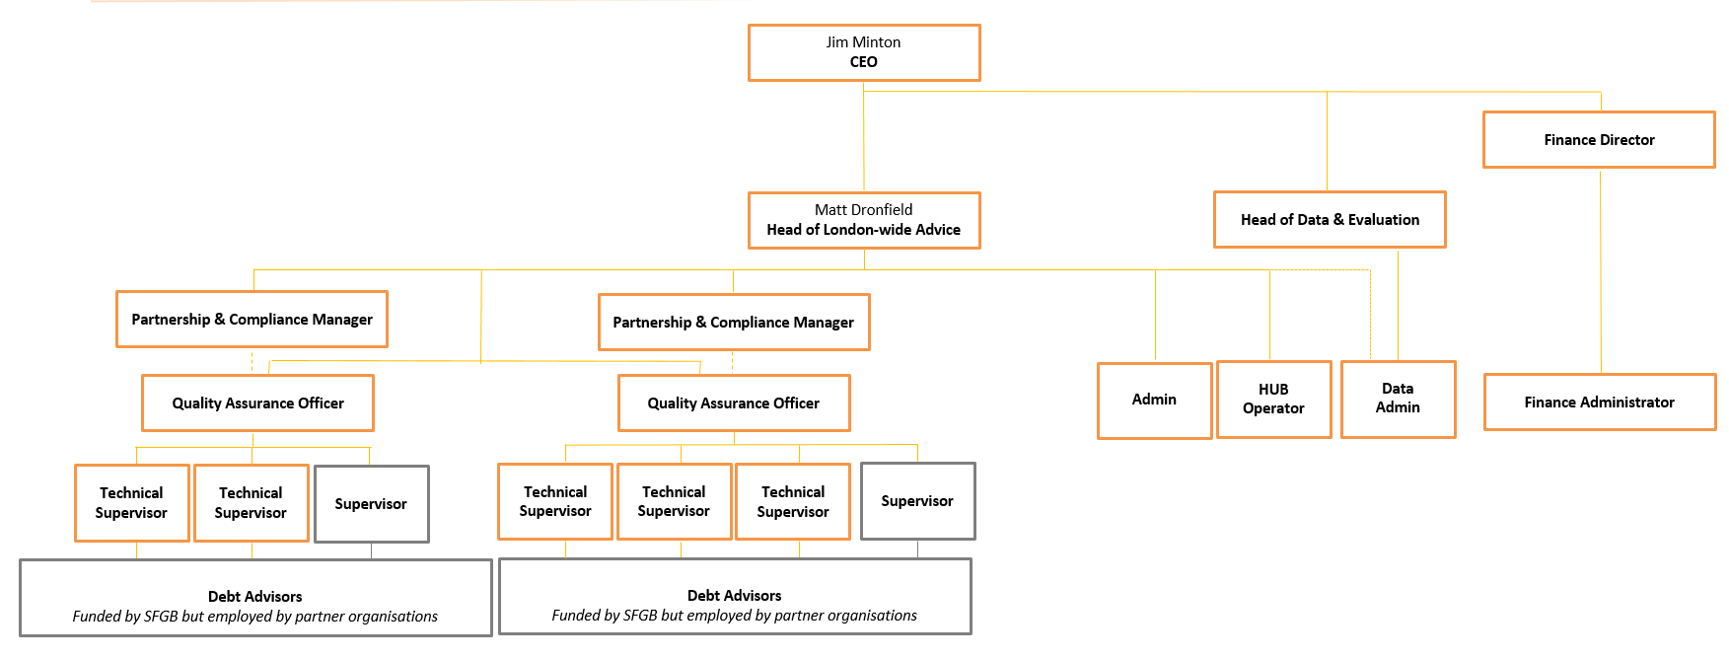

Main duties and responsibilities:

- Work with, and provide support to, partner organisations on an individual basis to improve the provision of consistent and high-quality debt advice
This includes:
- Ensure delivery partners understand funder requirements, including agreed volume of clients and quality key performance indicators in line with their Grant Agreement
- Monitor and measure delivery partners against these key performance indicators and analysing information gathered against risk ratings, quality frameworks and standards
- In instances where delivery partners are under performing - design, agree and liaise with delivery partners through, an improvement action plan
- Maintain an up-to-date risk register and meet regularly with the Head of London-wide Advice to review performance and advise on any actions to be taken

- Ensure payments to partner organisations are made each quarter in a timely manner
This includes:
- With the support of the Finance Officer, ensure all claims to funders are accurate and made in a timely manner
- With support of the Finance Officer, ensure accurate claims for payment are made on time from delivery partners, to ensure their payment is in lines with the terms of their sub-agreements
- Monitor and manage programme payment schedule
- Create participant related financial methodologies

- Ensure project compliance and quality requirements are achieved
This includes:
- Working closely with the Quality Assurance Officers to ensure delivery partners have a good awareness and understanding of the quality and service delivery requirements and have active involvement in the delivery of partnership events related to both quality improvement and CPD
- Working collaboratively to share good practice in performance and quality improvement and to progress key priority areas of work
- Escalating risks promptly and appropriately, and contributing to wider monitoring and reporting requirements

- Contribute to team
- Work to an agreed work-plan meeting targets and milestones
- Prioritise and manage your own workload
- Be an active member of the team, identifying opportunities for your own development
- Work in collaboration with our funder, and with colleagues from across their other funded organisations, contributing to key projects and meetings
- Compliance with Toynbee Hall policies and procedures, including health and safety
- Demonstrate financial efficiency and value for money throughout work
- Ensure that all services comply with equal opportunities and other relevant policies and quality standards and good practice

- Other
- Travel across London as required, and occasionally the UK
- Undertake additional tasks as defined by the Head of London-wide Advice and Toynbee Hall’s Senior Management Team

Person specification:

- Significant experience and skills in developing and managing partnerships including relationships both with partners, funders, peers and colleagues, and supervisors
- Strong skills and experience in developing data collecting tools, in assessing data quality and overseeing projects
- Significant awareness of the monitoring planned activities, conducting mid-term and final evaluation, and in the completion of data quality verifications and impact studies
- Experience of the monitoring, managing and evaluation of projects and performance
- Proven ability to work creatively to support change management using a solution-based approach that resolves issues and accomplishes goals.
- Experience of service and financial data inputting, reporting and analysis
- Experience of negotiating contracts and successful contract management
- Strong verbal and written communications skills with experience in cross- cultural settings
- An understanding of the Third/Charity sector, ideally with at least 2 years of experience working in this area
- Ability to make decisions, work under pressure on a number of competing tasks and meet deadlines
- Understanding how to work successfully in a complex political environment and on sensitive issues
- Ability to research, understand and explain complex information both orally and in writing
- Sets ambitious and challenging goals for him/herself, takes responsibility for his own personal development and encourages his team to do the same
- High standard of numeracy and computer skills, specifically with Microsoft Office Suite (Word, Excel, Access, PowerPoint, Outlook, MS Project) with an ability to understand and analyse complex financial and other numerical information
- Commitment to working flexibly across all Toynbee Hall’s services, including evenings and weekends

- Understanding of and commitment to Toynbee Hall’s values and equal opportunities policies

