FUNDRAISING WITH TOYNBEE HALL

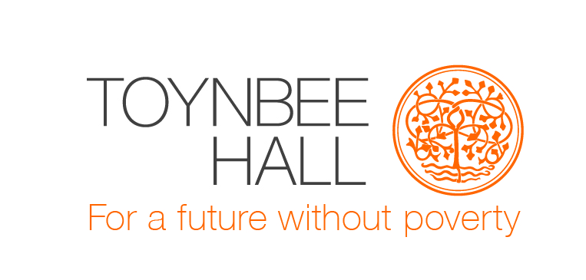
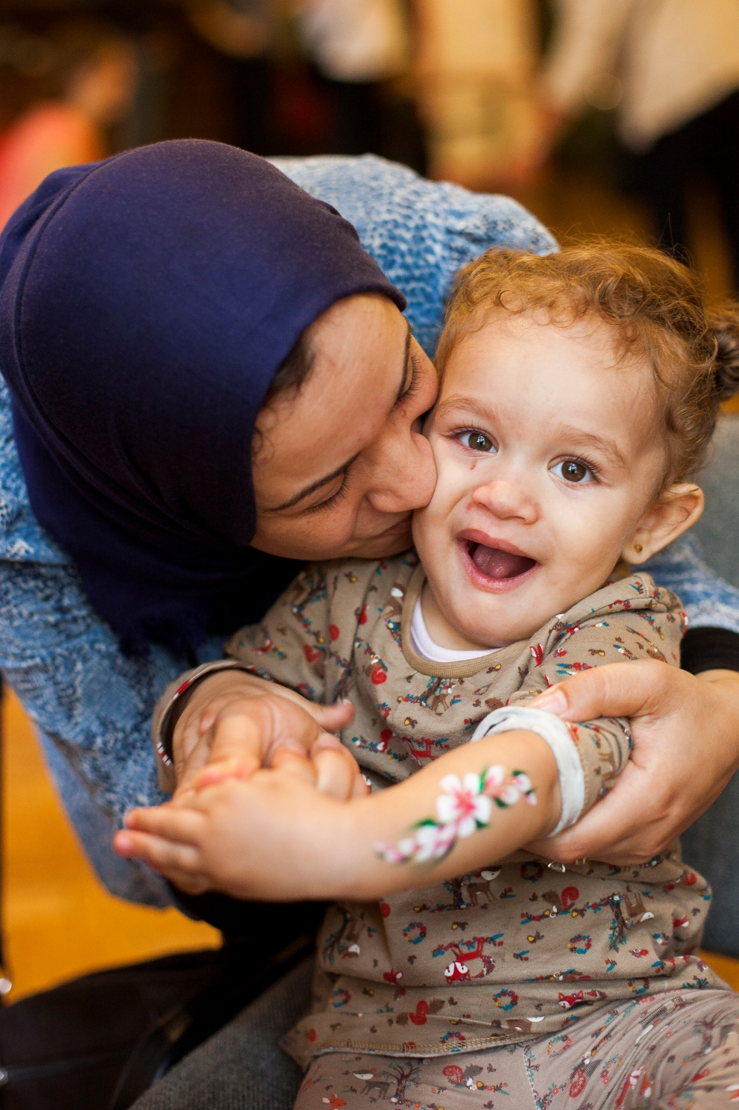
Make a change
Together we can change lives. Just one hop, skip or jump can make the biggest difference. Every penny you raise will go toward building a future without poverty. Make your mark today.

Toynbee Hall works on the frontline in the struggle against poverty. Based in Tower Hamlets in the East End of London, we give some of the UK’s most deprived communities a voice, working with them to tackle social injustice and providing access to free advice and support to those who most need it.
We work with everyone in the community. Last year we supported 12,000 people: older people who are facing a bleak future of economic struggle and social isolation, families consumed by debt, people at risk of abuse, people requiring free legal aid, migrant women who remain isolated in their communities due to language barriers and young people struggling at home and at school.
The need for Toynbee Hall’s services is greater now than ever.
Together we can work towards a future without poverty. Join us.
Contents
The difference you make
What you can do
Before you start

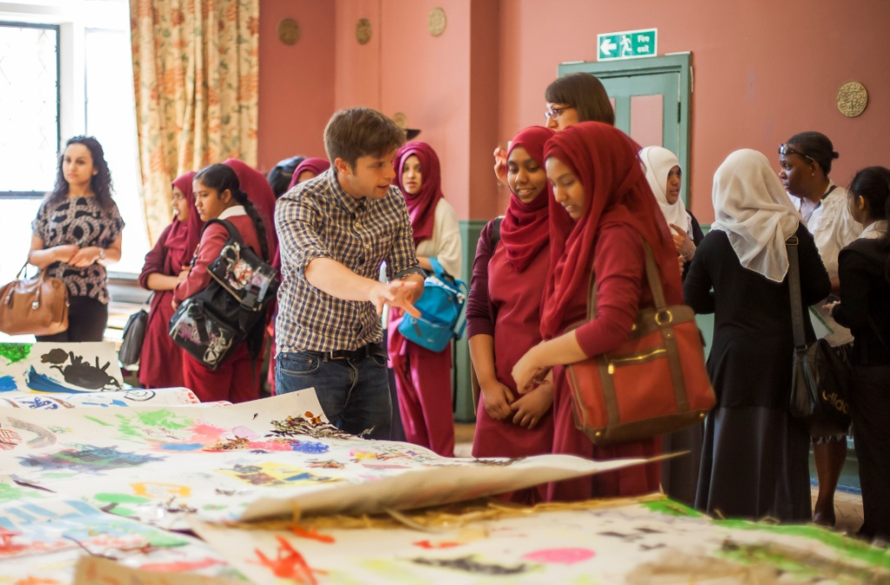
The difference you make
Jane was struggling to identify with herself and had been self-harming when she
was referred to Toynbee Hall’s youth project.

Jane felt like she didn’t ever fit in.
Her grades were dwindling and she
had reached an all time low.
Jane’s mother was worried about her future.
Following a series of workshops including a trip to
the Circus and Jamie’s Farm, Jane’s confidence and
self-esteem grew. She had the chance to flourish.
“There are small things, silly things that I’ve noticed about her that I didn’t see often before, like her smiling.” Jane’s Teacher.

Today, Jane is much more open and has grown
in confidence in all aspects of her life.
Jane’s mum has noticed a big change – she has
been happier recently and has stopped self harming.
£52 can help pay for group sessions for teenagers
to learn new communication skills together
and build better relationships with their peers.

Help us help young people
There are 400,000 young carers in the UK.
Kamrul is just one of them.
Since his father died, Kamrul had been looking after his mother who doesn’t speak any English. She needed help with simple tasks like grocery shopping and paying bills due to the language barrier.
At the age of 13, this was too much for Kamrul. He became timid and nervous in school. He couldn’t even make eye-contact with his teachers.
Toynbee Hall worked with Kamrul for one year. Kamrul took part in workshops and went on trips to the Circus and Jamie’s Farm. These activities helped him open up about his passion for drama.
Kamrul’s confidence has gone from strength to strength and he recently told us he had auditioned for a TV show and got the lead part!

£166 could pay for a young person to spend a day and night at Jamie’s Farm – the first trip out of London for many.

“I have learned that I am special in my own way and that I can be more confident at times.” Participant, Toynbee Hall Youth Programme

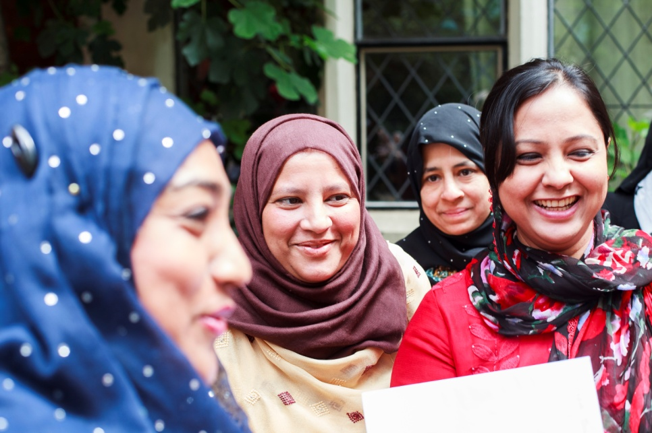
What you can do
There are so many ways you can raise money to help us tackle poverty.
Organise an afternoon tea for friends and neighbours, a quiz night at your local pub, or get sponsored to dress up at work.
Not adventurous enough? Why not sign up for a fun 5k Santa Run? Or keep it traditional with a cycle ride from London to Brighton.
Visit http://www.toynbeehall.org.uk/fundraise-for-toynbee-hall for our events listings

Go on, take the plunge...
Getting your money to Toynbee Hall
- Online: Fundraising online is fast, easy and secure. Set up your page via JustGiving.com/ToynbeeHall. You will be able to start raising funds for Toynbee Hall right away. You can send the link of your fundraising page to your friends and family and add it to your Facebook and Twitter accounts. The money raised on your page will go directly to Toynbee Hall.

- Paying It In: After you have collected your money from your sponsors, you can send it in to us by
- Post: Send a cheque/postal order/Charities Aid Foundation voucher to Toynbee Hall, 28 Commercial Street, London E1 6LS
- Phone: Call us at 020 7392 2949
- Email us at fundraising@toynbeehall.org.uk and we will be able to give you details on how to transfer funds directly to us.

£208 can pay for four weeks of one-to-one
mentoring sessions for a vulnerable teenager,
helping them to develop coping strategies
and plan for their future.

Gift Aid allows us to claim back 25% tax on every eligible donation.
That means for every £1 you raise, we’ll be able to claim at least an extra 25p. Encourage your supporters to select the Gift Aid donation to help you reach your target faster.

Tell the world
Don’t be shy!
Everyone wants to know what you’re up to.
Spread the word using:
Twitter, Facebook, Instagram, Vine and whatever else you cool kids are using these days. Don’t forget to tag @ToynbeeHall.
Local Press: Contact your local newspaper to see if they would like to write about your fundraising. It’s a great way to advertise what you are doing and may even help you to promote your activities to new supporters.

Need some help?
If you’re planning an event of your own get in touch with our team and we’ll support you on your journey to ensure you get the most out of it.
Email us on fundraising@toynbeehall.org.uk or give us a call on 020 7392 2949.

Before you start
Here are few things to check before organising an event:

Food and Drink:
- If you are providing food, please make that it has been prepared, cooked and stored. Visit www.food.gov.uk for more information.
- If you want to sell alcohol at your party, you’ll need a licence. Most venues will have a licence but be sure to check.

Be Safe: Whatever you have planned to raise funds for Toynbee Hall, please do it safely. Toynbee Hall cannot accept liability for any loss, damage or injury as a result of fundraising for us.

Keep It Legal:
- Check the legal requirements for entertainment with your local authority and/or venue.
- Door to door and street collection is not permitted without approval from your local authority.

Safe Guarding Children: Please take extra time to plan fundraising activities involving children. Any fundraisers under the age of 18 should have their parent or guardian’s permission to take part.

Any questions? Get in touch via fundraising@toynbeehall.org.uk or call 020 7392 2949
Health and fitness tips. From us, to you.
Good carbs?
Good carbs are complex carbohydrates. These break down into glucose at a slower rate and keep you energised for longer without making you feel lethargic.
- Wholegrain products
- Fruits, vegetables, lentils, pulses and beans
- Stay hydrated. 2litres of water a day will keep you going.
- 6 small meals a day will keep you fuller for longer.
  - Protein, veggies, good carbs and healthy fats.
- Oats are your friend. Have a hearty breakfast of
Oatmeal or porridge to set you up for your day.
- Visit www.food.gov.uk for more information

Keeping Fit
Healthy fats?
Not all fats are bad. Monounsaturated fats, polyunsaturated fats, and omega-3s have all the good qualities of fat.
They play a huge role in helping you manage your moods, stay on top of your mental game, fight fatigue, and even control your weight. Examples include:
- Olive/Coconut/Sesame Oil
- Avocado
- Nuts
- Sunflower seeds
- Fish i.e. salmon
- Train. If you’re signing up for a run, cycle, walk or any
other heavily exertive activity, you have to train so your
body doesn’t receive a massive shock on event day.
- Sensible shoes. Always exercise in suitable trainers.
They don’t all cost a fortune.
- Interval training can be a good way to build up stamina
and resistance.
Always speak to your GP before making a big change to your diet or exercise routine.

Go on, take the plunge...
A big Toynbee Hall thank you!
Without you, we wouldn’t be able to make such a difference to the lives of so many people. Thank you so much for all of your hard work.
Together, we are working towards a future without poverty.

Registered Charity Number: 211850
Toynbee Hall
28 Commercial Street
London
E1 6LS
www.toynbeehall.org.uk
fundraising@toynbeehall.org.uk
020 7392 2949

